# Design Document

## High Level Diagaram:

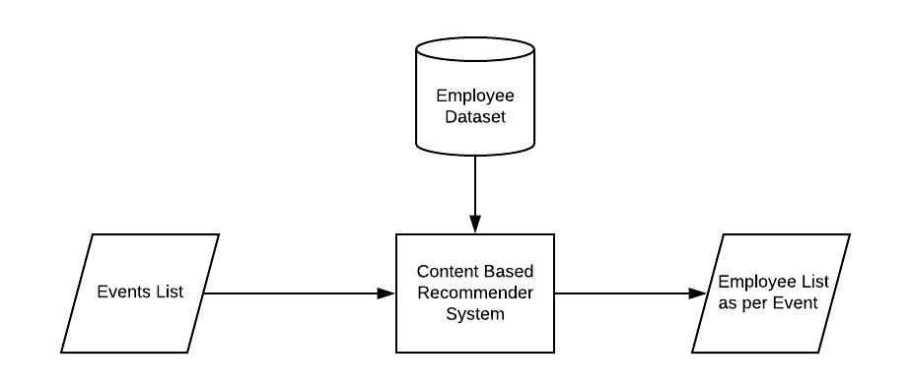

System will take list of events as an input and will process it for giving recommendation to the internal employees based on their domain and event type choice as specified them. System will create list of employees for each input event in list of events.

## Functional Flow Diagram:

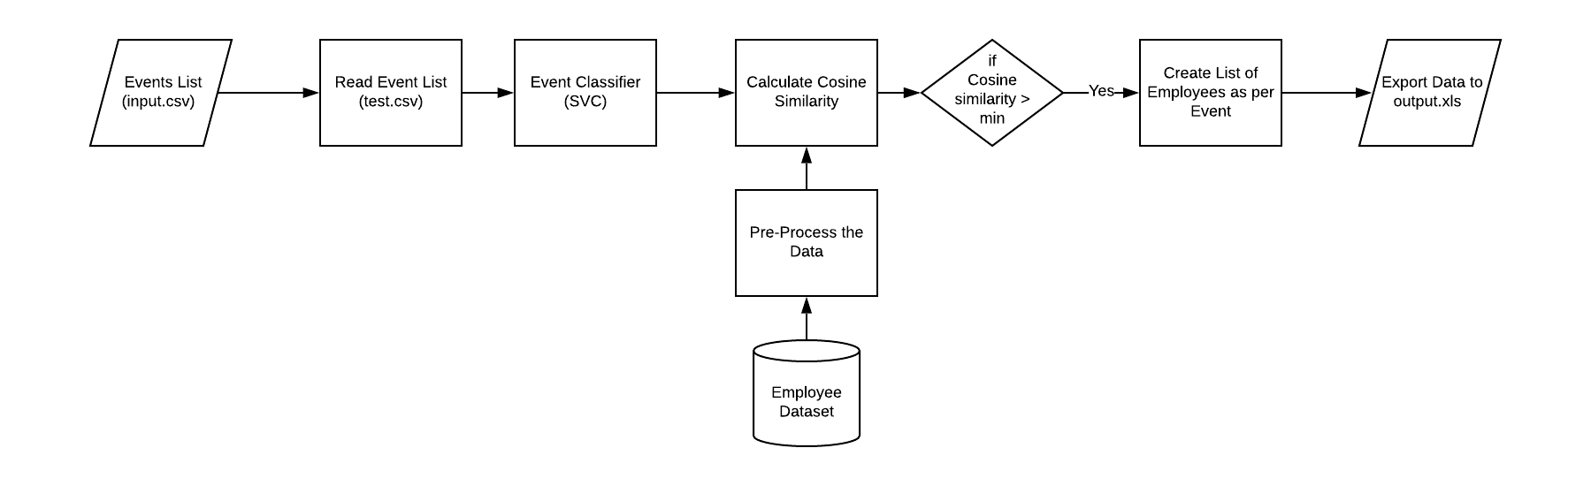

## Component Diagram:



## Description:

1. System will take number of events as input from csv file and import it into pandas Data Frame.

2. Each event from input file will be classified into various classes according to domain and events using SVM as Classifier. In SVM we classify non-linear data. The nonlinear data will be represented into n-dimensional space using kernel tricks. Then maximum-margin hyperplane will be generated to classify data into classes.

3. The class (Domain and event type) of the input event will be checked with employees’ preferences using cosine similarity. Class of the input event (eg. Machine Learning Certifications) and Employees’ selected domain and event type will be converted into vectors using CountVectorizer. Cosine similarity method calculates cosine angle between those 2 vectors.

4. Based on cosine similarity score of employees, the list employees with maximum score will be stored in list.

5. Then list of employees with maximum score will be stored into MS Excel file using xlsxwriter library.

## Data Design:

### **Input – input.csv**

|  |  |  |
| --- | --- | --- |
| **Sr. No.** | **Name of Field** | **Objective** |
| 1. | Event | To describe and store event information. |

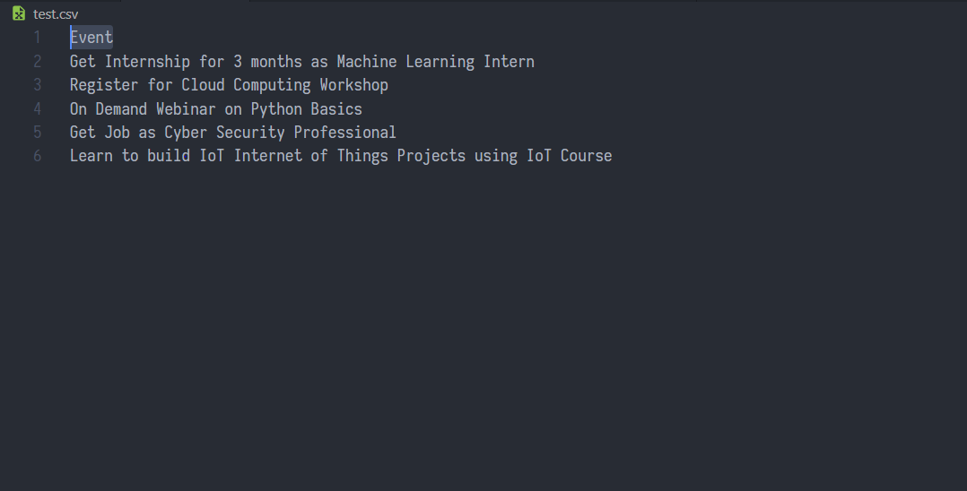

**Output – results.xlsx**

|  |  |  |
| --- | --- | --- |
| **Sr. No.** | **Name of Field** | **Objective** |
| 1. | Event | Description of Event |
| 2. | Employees | List of recommended employees for Event. |

